

Lab 8

VPN Lab- pfSense Setup

ITSC 206: Advanced Networking for Offensive and Defensive Environments

Table of Contents

Lab Setup 2

Files/Download 2

Reading 2

Introduction 2

Use pfSense Firewall VM IDPS Setup 2

Firewall IDPS (Snort) Installation 3

IDPS Snort Setup 7

Kali OpenVAS 13

Lab Setup

* Review architecture for each configuration and optimize.

Files/Download

Reading

* [https://doc.pfsense.org/index.php/Installing_pfSense#](https://doc.pfsense.org/index.php/Installing_pfSense)
* https://doc.pfsense.org/index.php/OpenVPN_Site_To_Site

Introduction

This document supports the setup of Lab8 VPN. Use Lab7 to setup document to initially pfSense Firewall.

Use pfSense Firewall VM IDPS Setup

Setup pfSense with the following attributes in the VM Player:

1. Shutdown the VM of the firewall and then change the Network Adapter LANSegment1 or NAT (WAN) to Bridged

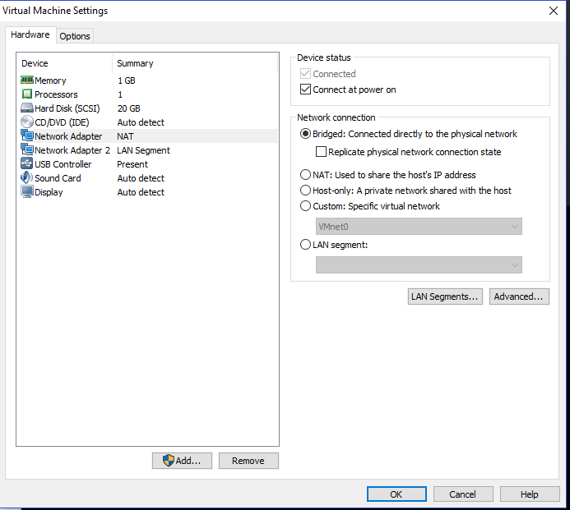

1. Restart the pfSense Firewall VM, confirm that the WAN interface gets an IP address via DHCP, you may need to use step 11 of Lab6 Setup doc and setup DHCP

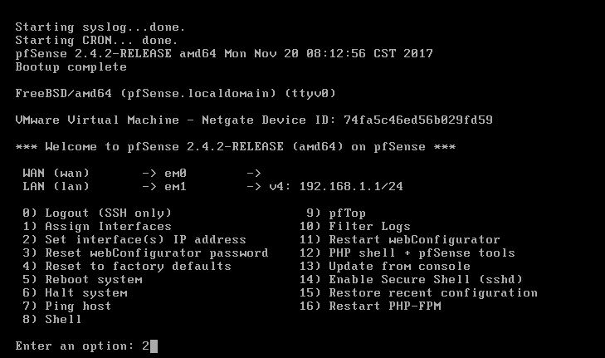

1. Start up the Firewall

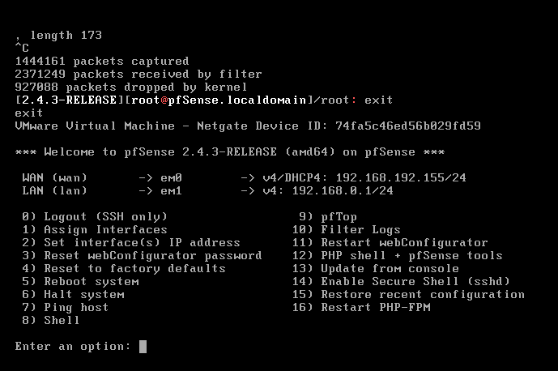

Firewall VPN (OpenVPN) Installation (Server) one side

Setup pfSense with OpenVPN following these steps:

1. pfSense Change LAN interface

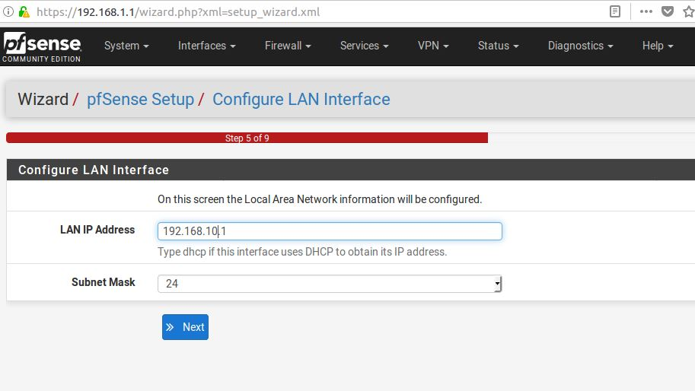

1. From the pfSense Firewall interface, login and select VPN->OpenVPN

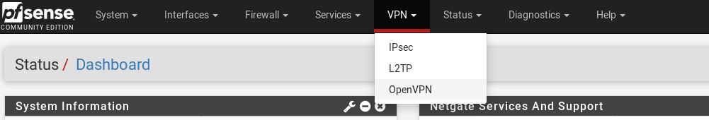

1. Click on OpenVPN -> Wizards setup

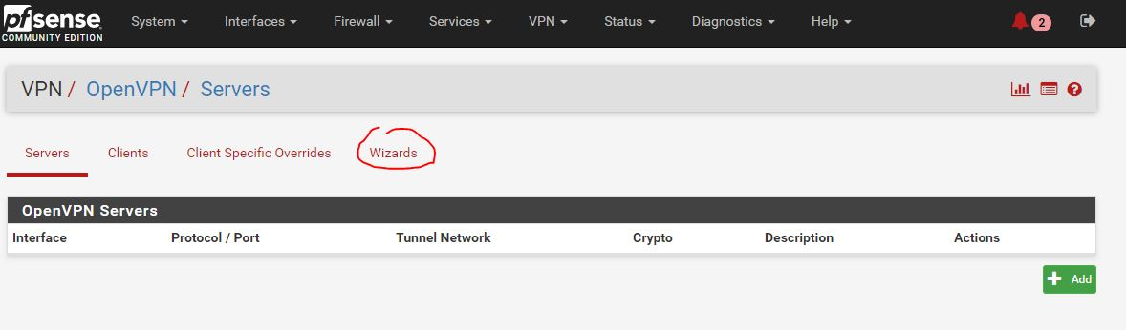

1. pfSense OpenVPN Remote Access Server Setup -> Add Certificate Authority, Add new CA

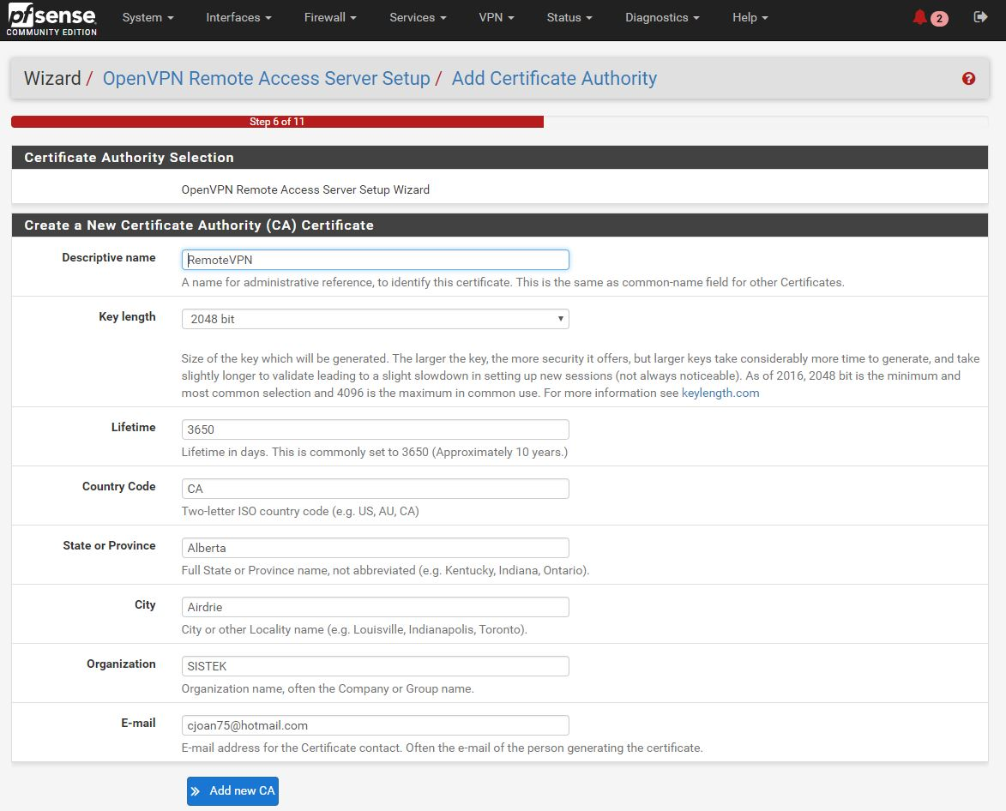

1. pfSense OpenVPN Remote Access Server Setup -> add your own details, Create new Certificate

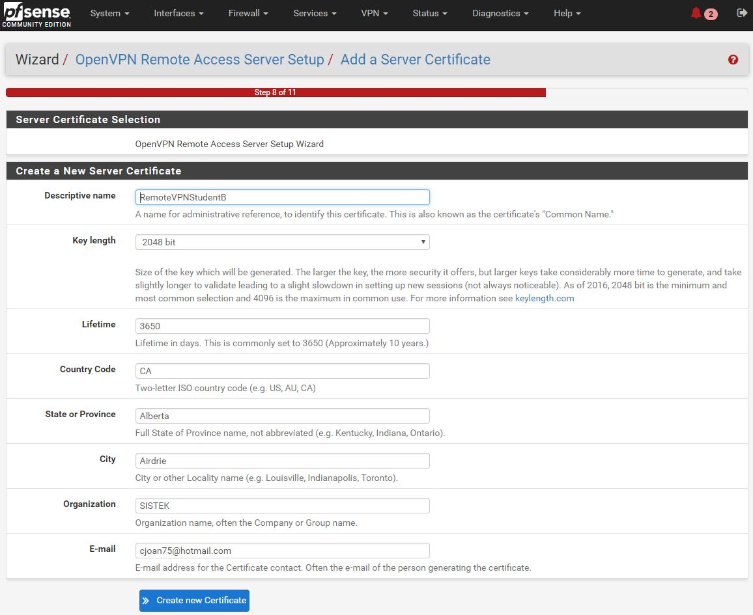

1. pfSense OpenVPN Remote Access Server Setup -> Server Setup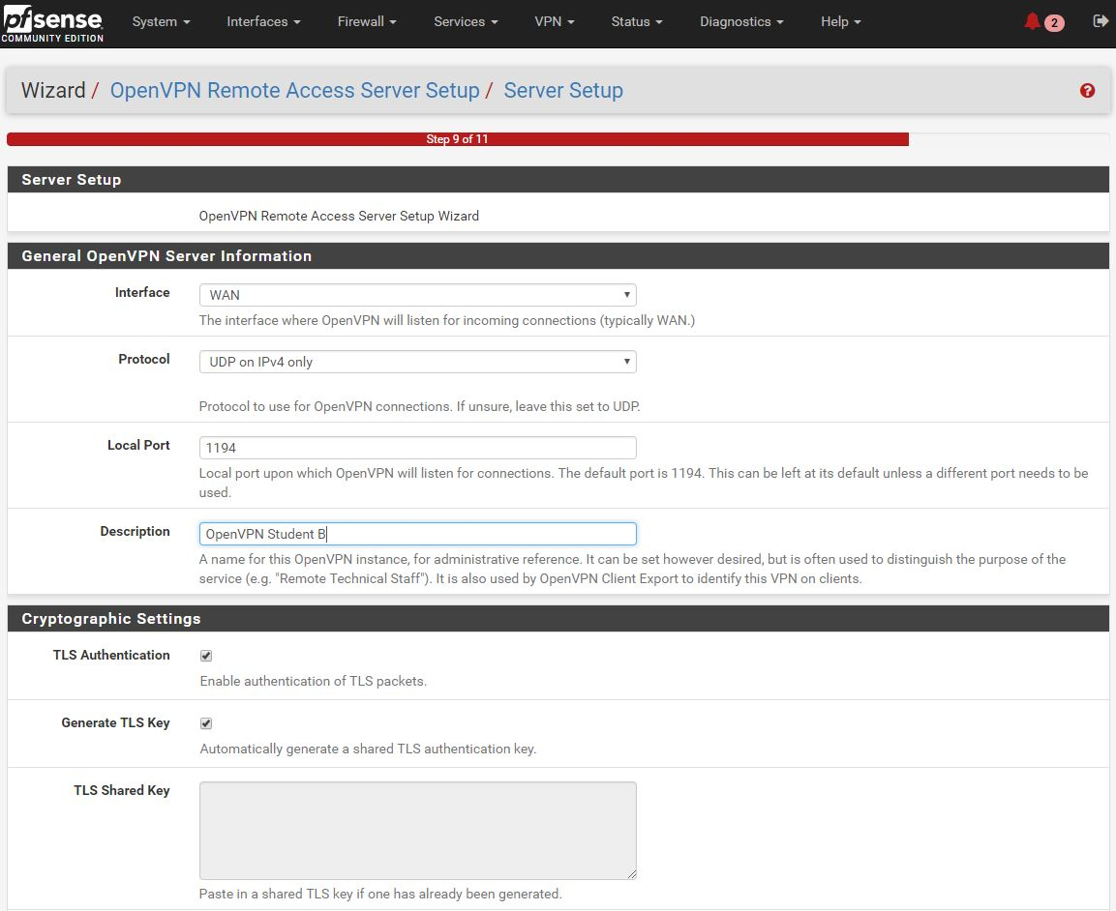
2. pfSense OpenVPN Remote Access Server Setup -> Server setup continued

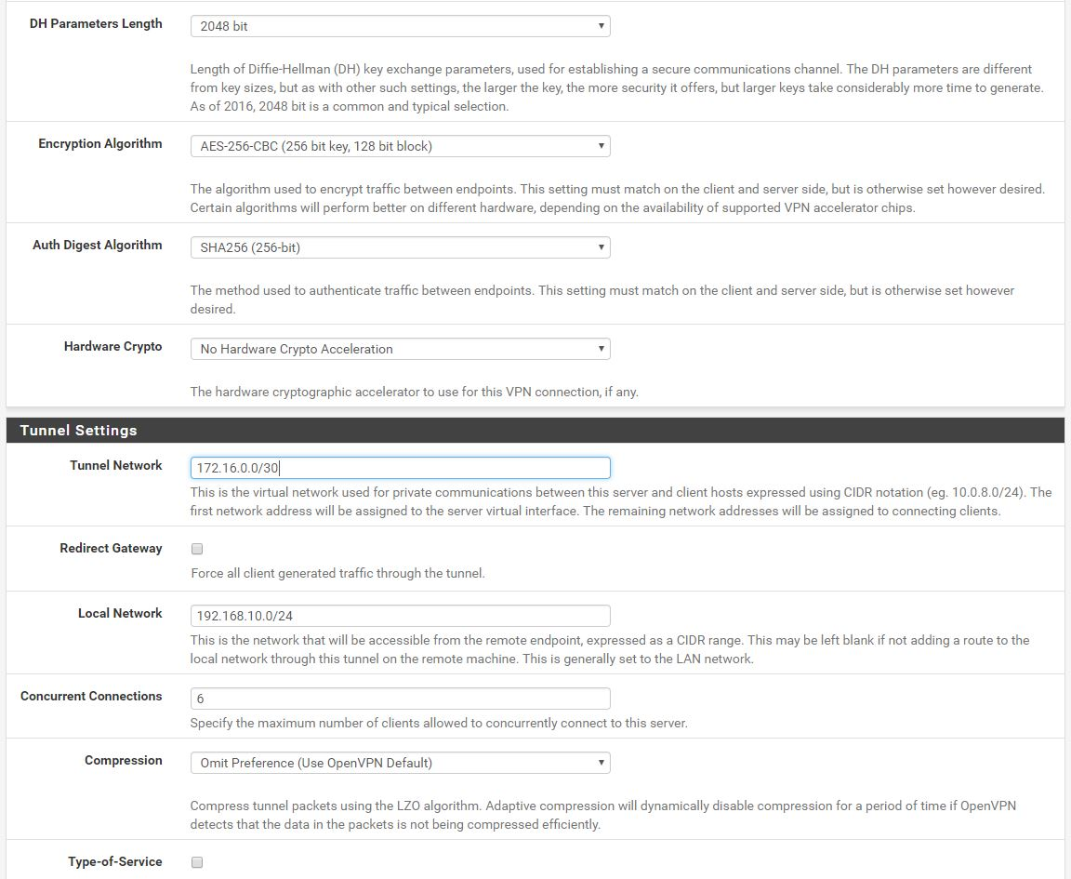

1. pfSense OpenVPN Remote Access Server Setup -> Server setup continued

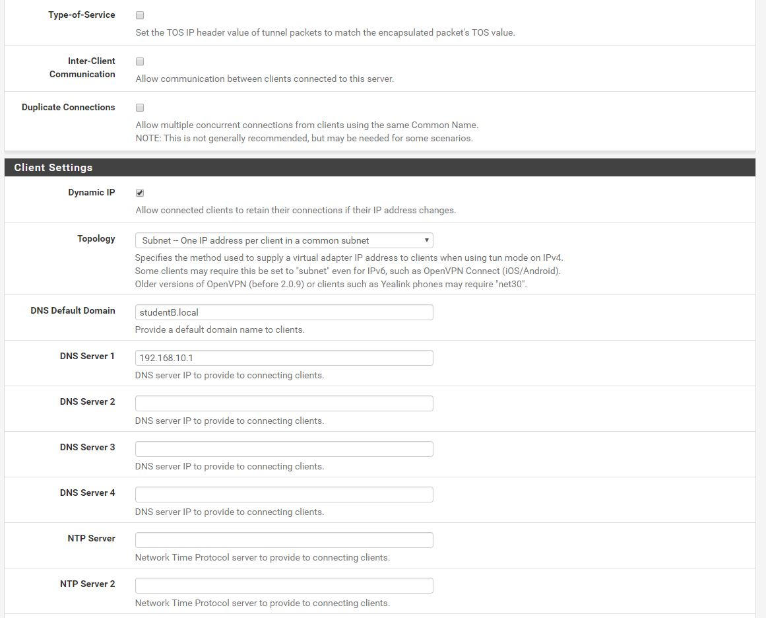

1. pfSense OpenVPN Remote Access Server Setup -> Firewall Rule Configuration

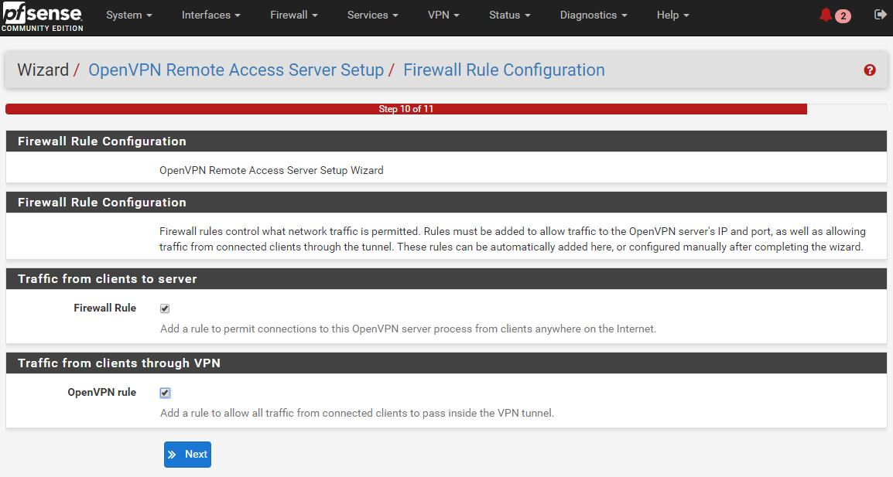

1. pfSense OpenVPN Remote Access Server Setup -> Finished

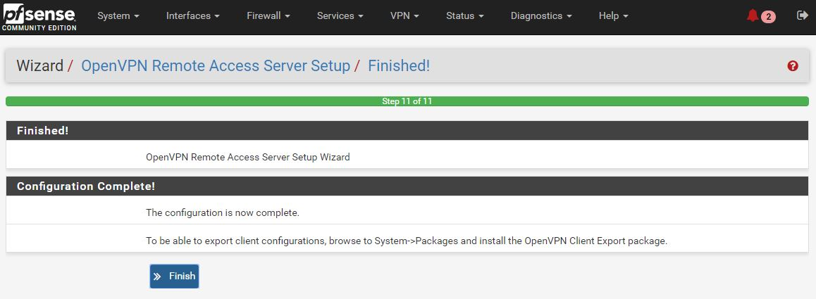

1. a

OpenVPN Client Setup (other system)

1. pfSense OpenVPN Clients click on Add 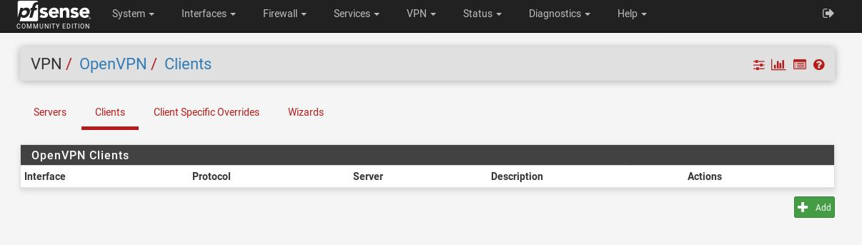
2. pfSense OpenVPN Clients Edit

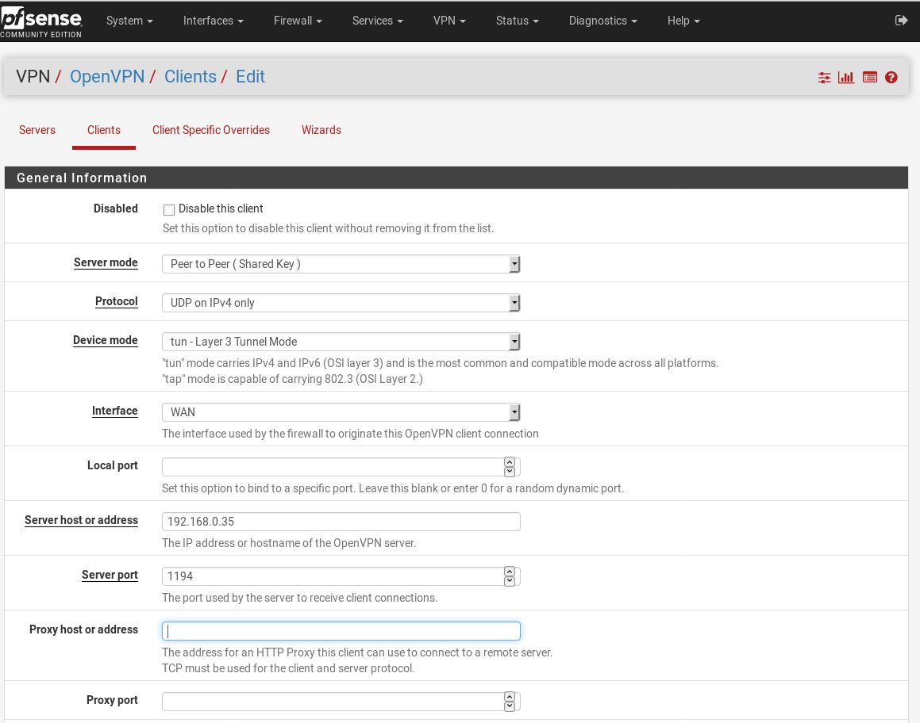

1. pfSense OpenVPN Clients continue

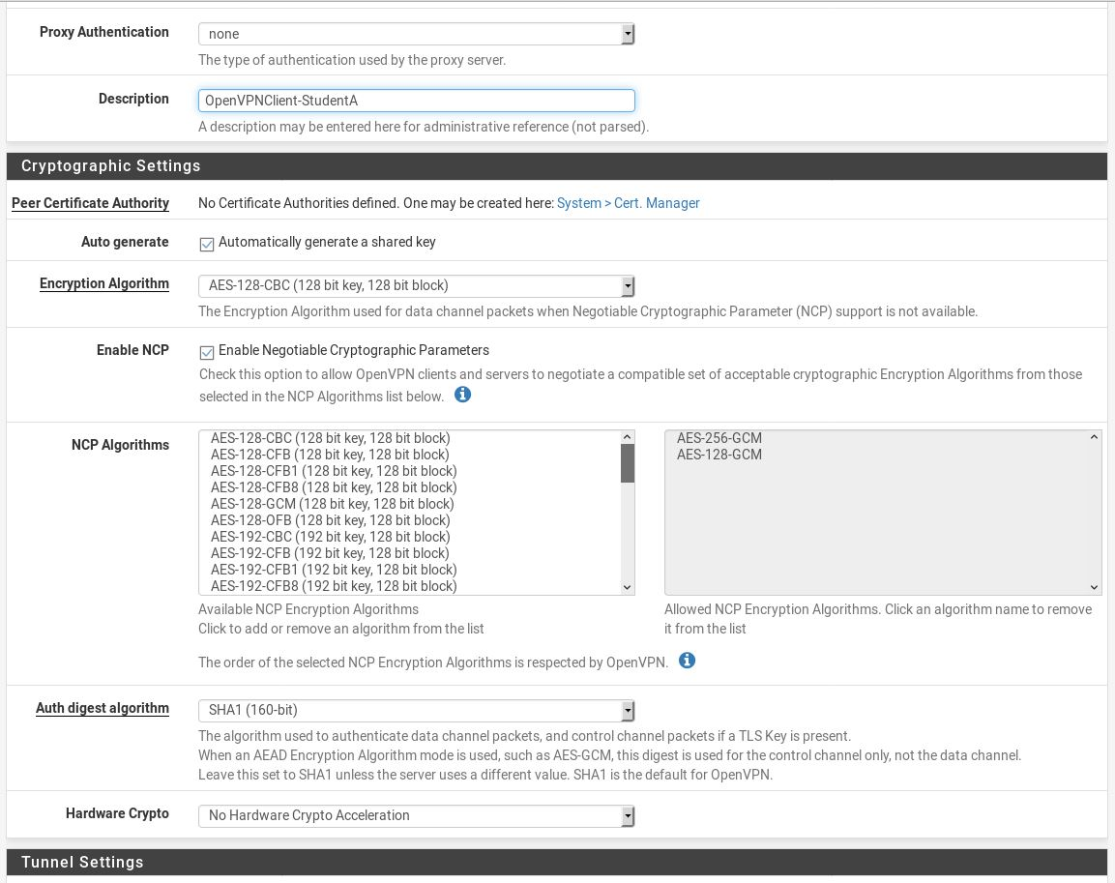

1. pfSense OpenVPN Clients, notice ipv4 Tunnel Network, ipv4 Remote network (s)

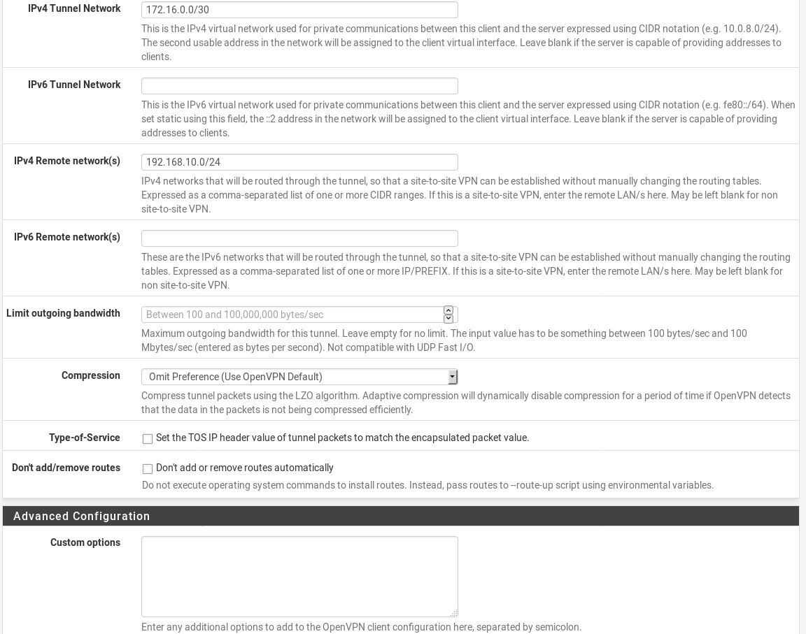

1. pfSense OpenVPN Clients, click on Save

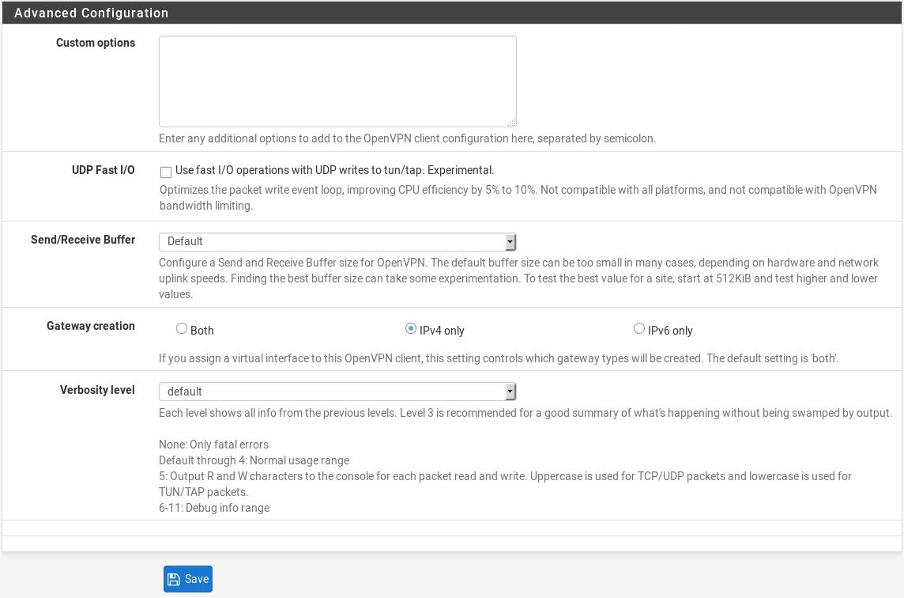

1. pfSense Interfaces, click Add on OpenVPNClient-StudentA, then click Save

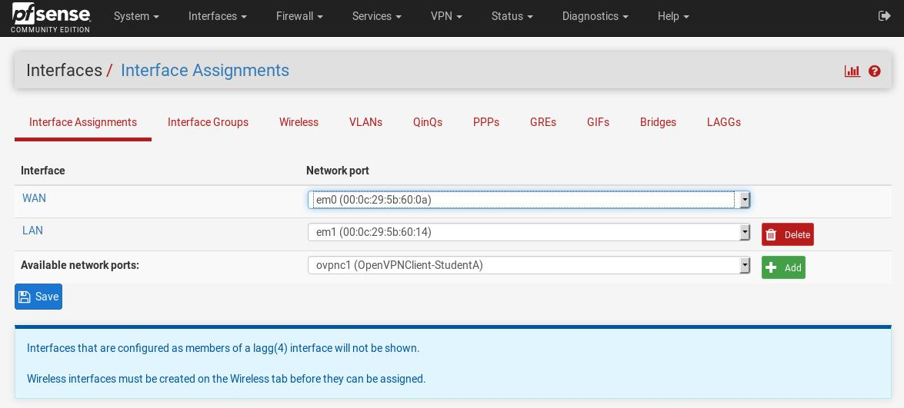

1. pfSense Double click on ovpnc1 Interface, to edit

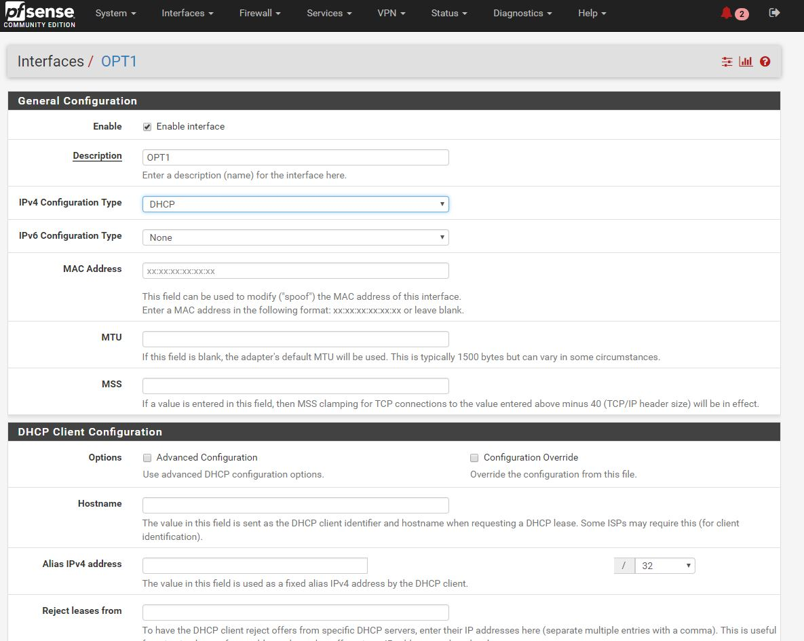

1. pfSense Interfaces OPT1

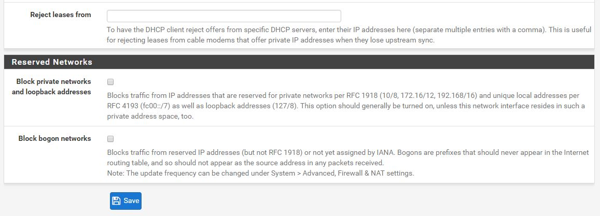

1. pfSense Firewall Rule, edit for OpenVPN

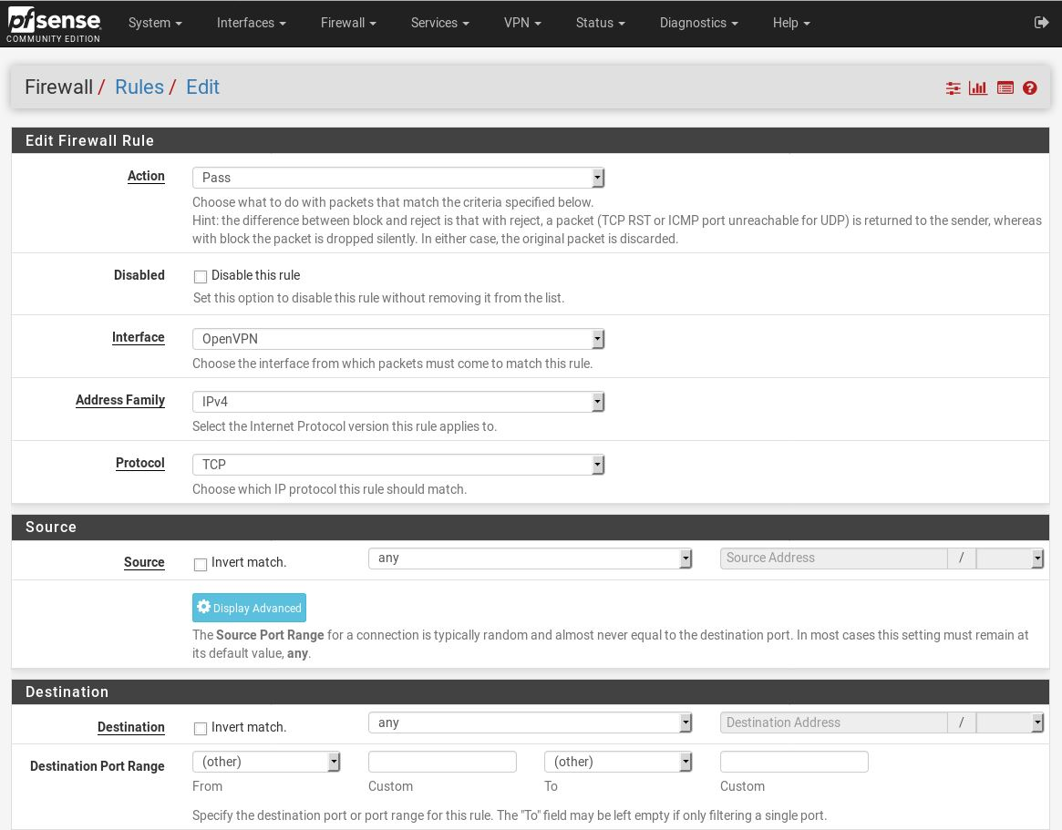

1. pfSense Firewall Rule, edit for OpenVPN, click Log and Save

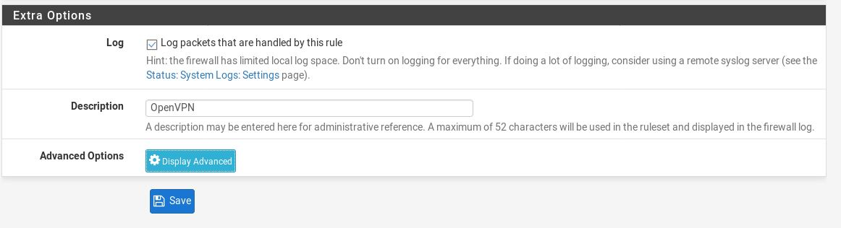

1. a

Hints:

**DO NOT DELETE THE SECTION BREAK BELOW. DELETING IT MAY IMPACT THE FORMATTING IN THIS DOCUMENT.**